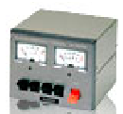
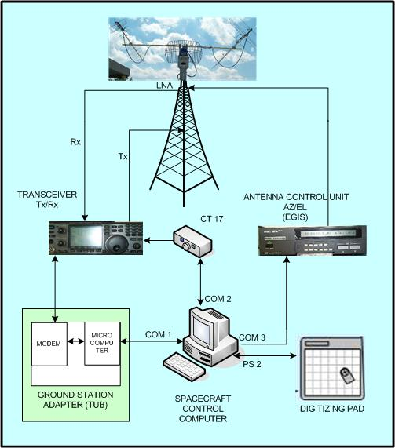

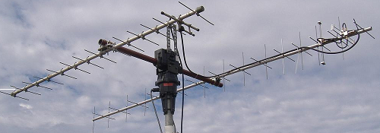
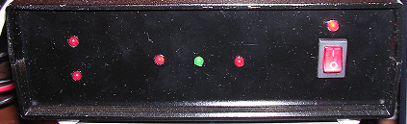
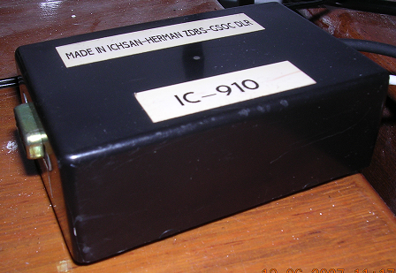
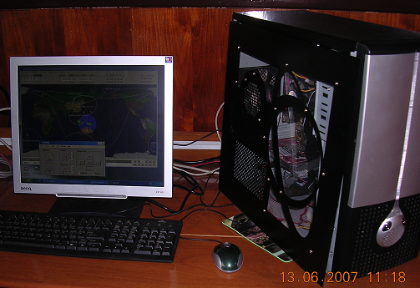
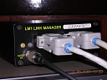
LAPAN
BOGOR
MONITOR TV
Antenna
8 feet
Yaesu
G-5500
CONFIGURATION SYSTEM TRACKING LAPAN-TUBSAT
RECORDER
VCD/DVD
LNA
VIDEO RECEIVER

